Corey Gaspar
2/28/2026
Module 8-1 Assignment: Creating Data Aggregation Pipelines
I navigated to the datasets folder in Codio and imported the “companies.json” file, creating the companies database and the research collection. I then switched to use the companies database. 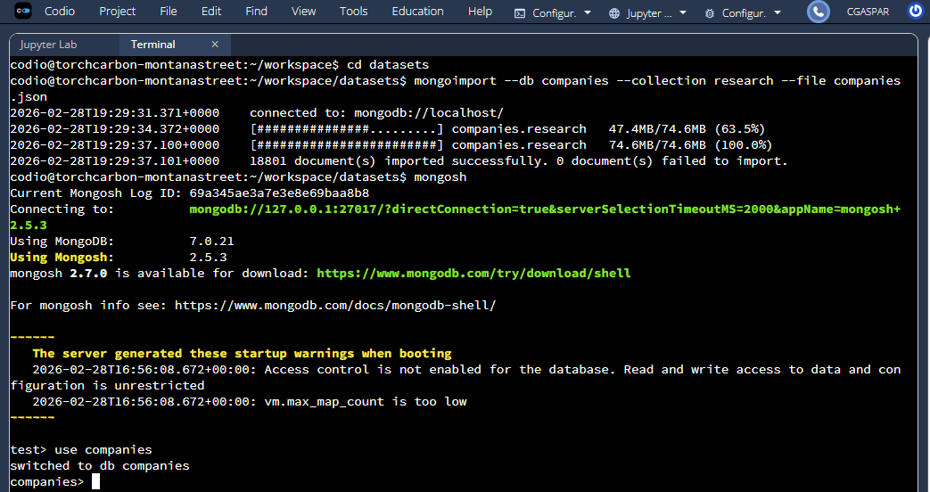

In the Mongo Shell, I verified my load by querying the company named AdventNet to view all information about the company.
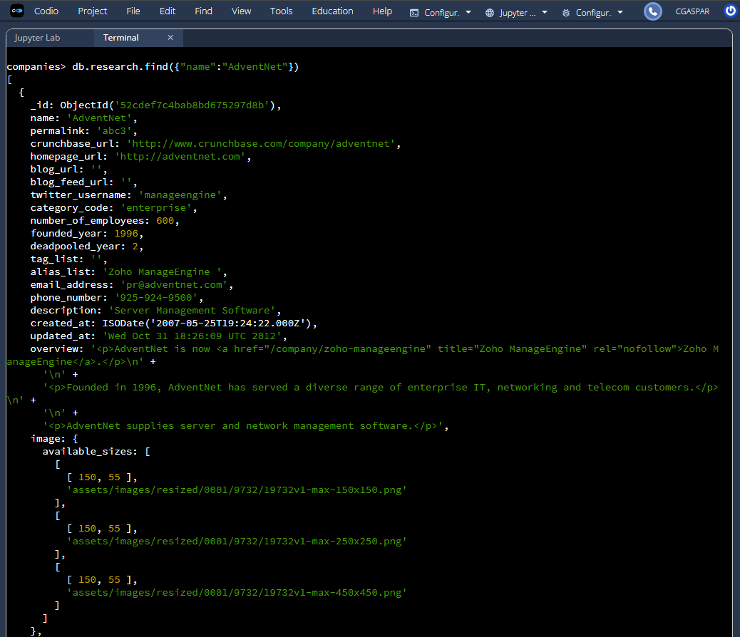
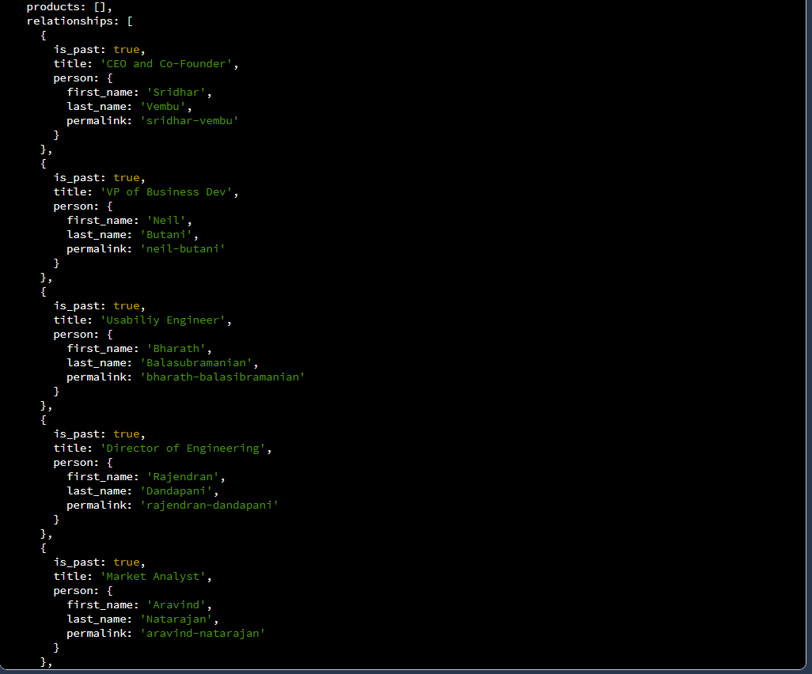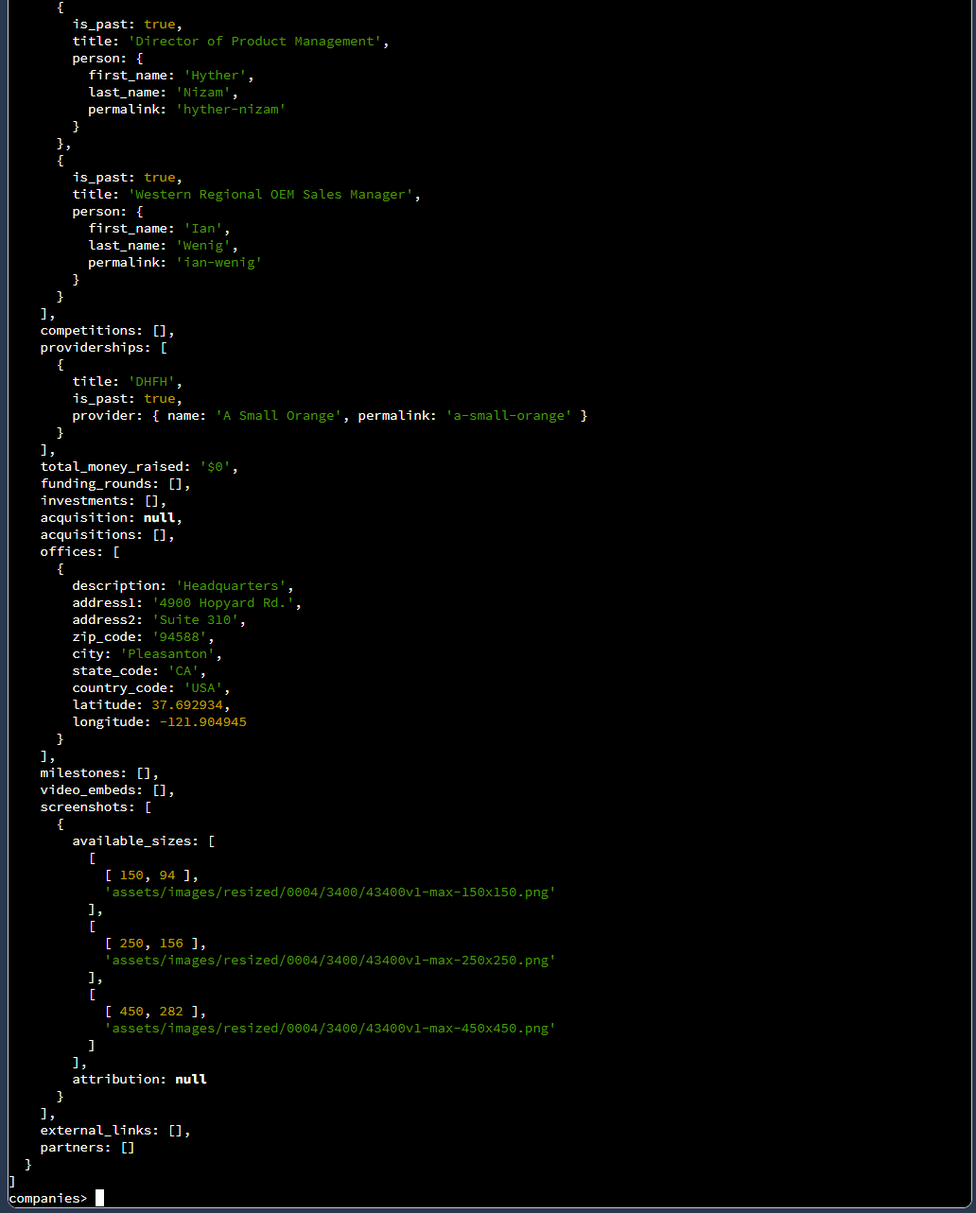

I ran a query to retrieve the first 10 companies founded in 1996, showing their object ID and their names.
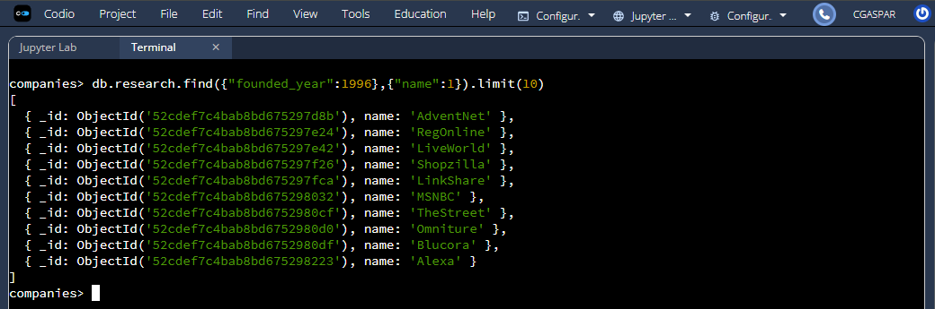
List only the first 20 names of companies founded after the year 2010, ordered alphabetically.
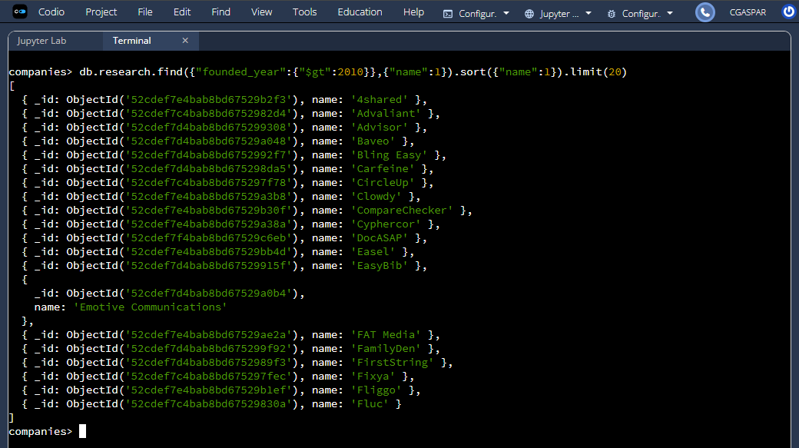

List only the first 20 names of companies with offices in either California or Texas, ordered by the number of employees and sorted largest to smallest.
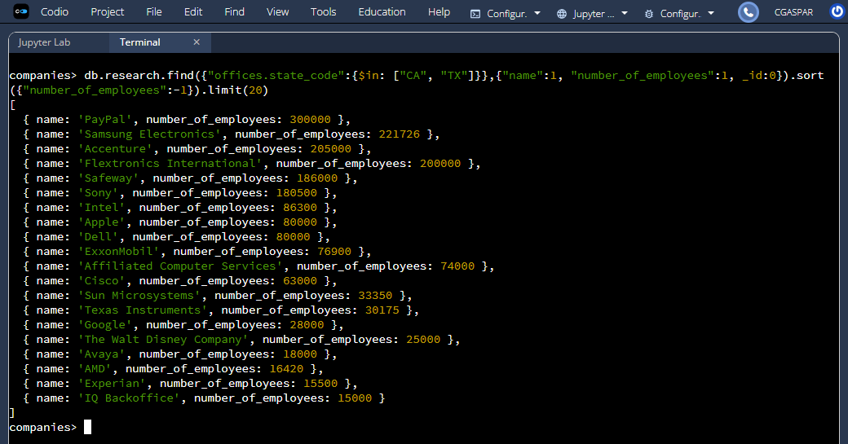
The pipeline first separates each office into its own document using unwind, then filters only U.S. offices using match. It groups the offices by state and counts them with group, and finally sorts the states from most to fewest offices using sort. (Screenshot on next page)

